How to get Admin Access token

- We want Token from Keyloack and get it from java call

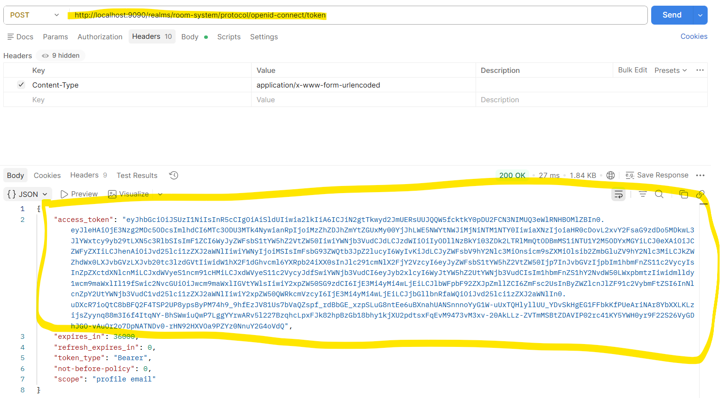

- Setup property in java

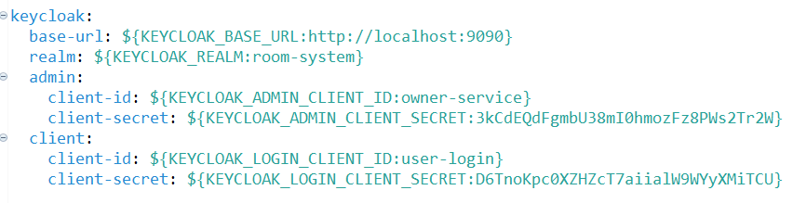

- Create config record to get the property: that need to be the same what inside the property above
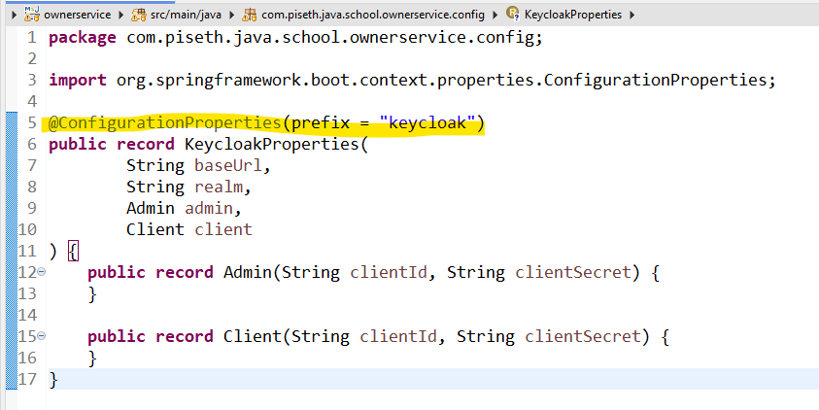

- Get the property to the java : KeycloakConfig

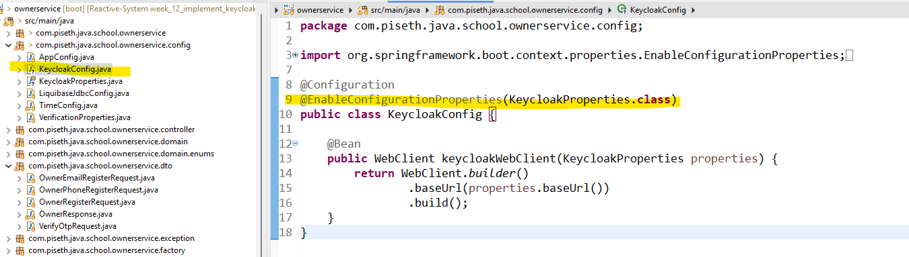

- Get Admin Token: create interface

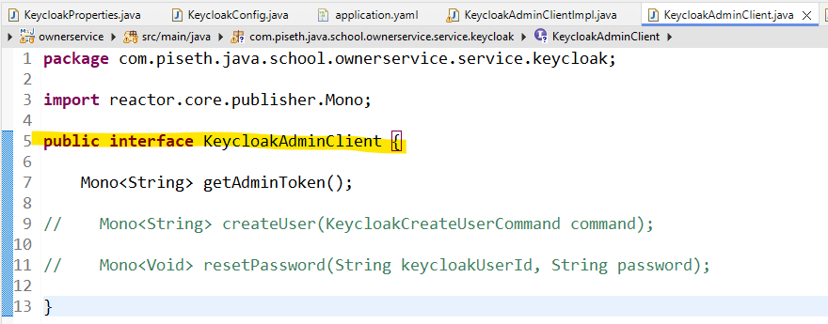

- Impl
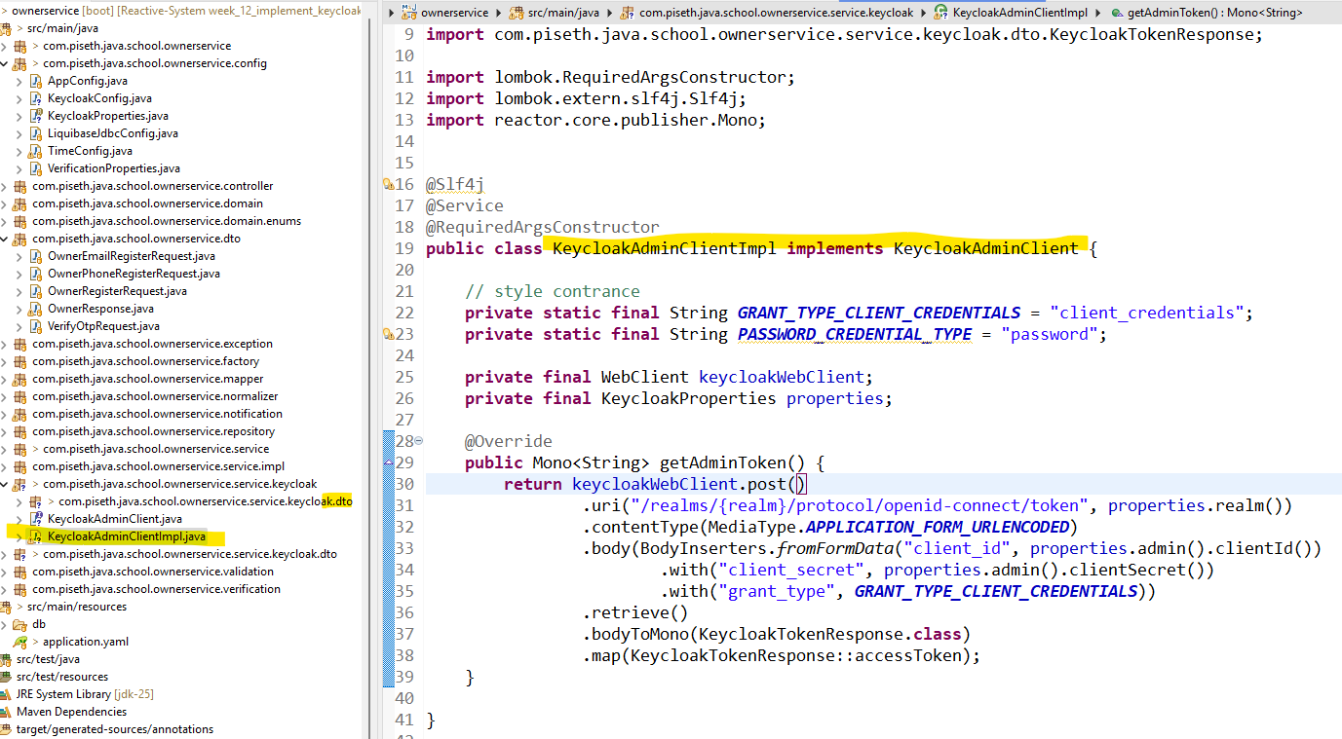

1-1 Frist we need: WebClient

keycloakWebClient.post()
.uri("/realms/{realm}/protocol/openid-connect/token", properties.realm())
- keycloakWebClient យើងប្រើ Method Post យើងដាក់មក ហើយយើងដាក់ URI វា
- {realm} គឺយើងធ្វើ Binding វា ទៅនឹង properties.realm() ដែលយើងអាចពិនិត្យមើលទៅ វាជា​ realm: ${KEYCLOAK_REALM:room-system}

- .contentType(MediaType.APPLICATION_FORM_URLENCODED) យើងត្រូវដាក់វាអោយភ្ជាប់ ទៅនឹង request header
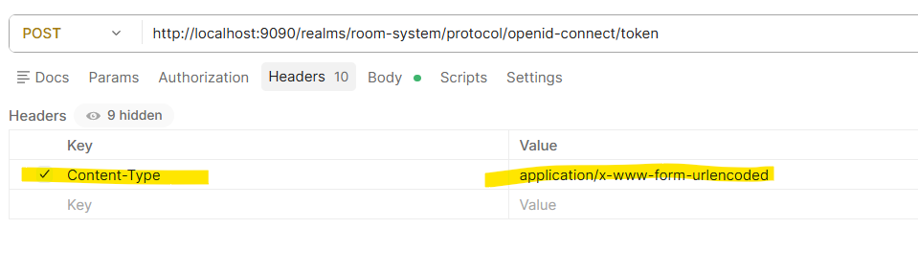

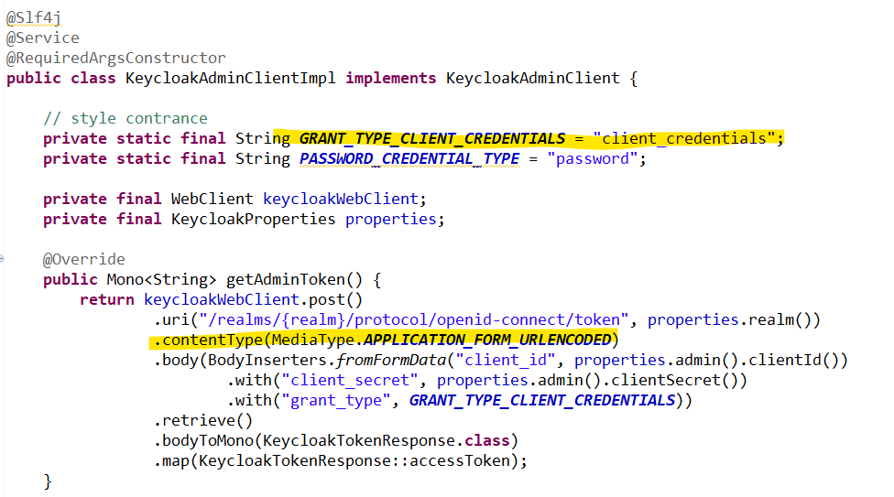

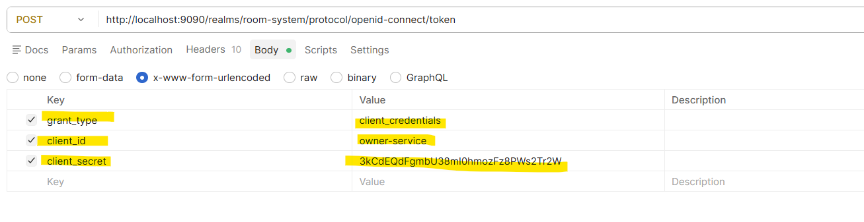

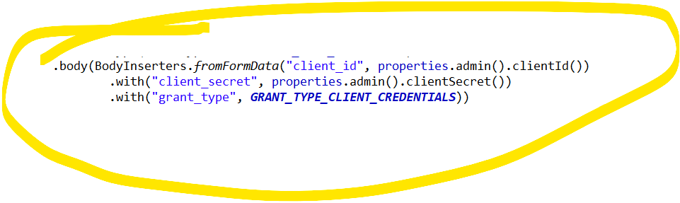

តាមរយៈ properties> យើងអាចធ្វើការទាញ ទិន្នន័យពី property បាន ហើយវា flexible

- អានឹងវាជា Component to get the token from Java

II. Create Controller to get Admin token
